

For the following, sketch the graph of the derivative
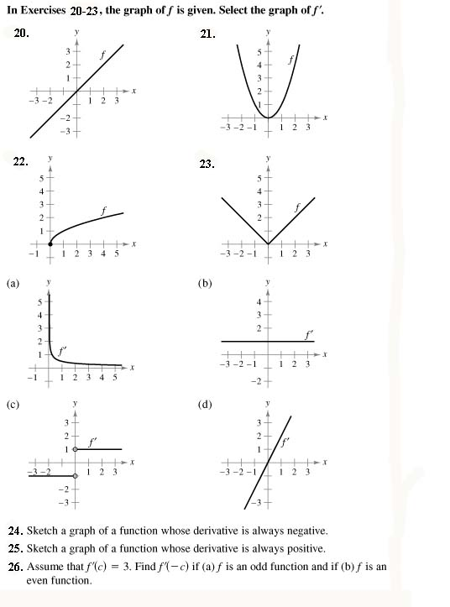
2.
1.

3.
4.

Use the power rule to differentiate the following:
10. $y=8x^{\text{10}}$ 11. $y=x^{2}+4x^{3}$ 12.$y=\text{18}x^{3}+\text{12}x+\text{11}$
13. $s=t^{3}−2t+4$ 14. $y=\frac{1}{2}(x^{\text{12}}+\text{17})$ 15. $y=−\frac{1}{3}(x^{9}+2x^{3}−9)$
16. $y=x^{2}+5−3x^{−2}$ 17. $h=s^{4/5}−s^{2/3}$ 18. $y=\frac{3}{x^{2}}$
19. $y=\frac{1}{x^{7}}$ 20. $y=\sqrt{x}$ 21. $y=\sqrt[7]{x}$
22. $y=\sqrt{x}−6\sqrt[3]{x}$ 23.$y=\frac{1}{\sqrt{x}}$ 24. $s=t^{2}−\frac{4}{t^{3}}$
25. $y=x(x^{2}+1)$ 26. $y=\frac{x^{3}−3x^{2}+4}{x^{2}}$ 27. $y=(2x+1)^{2}$
28. $y=(4x^{2}+1)^{2}$ 29. $y=(x^{5}+3x)^{2}$ 30. $y=(6x^{2}+3)(\text{12}x−4)$
31. $y=(3−x−2x^{3})(6+x^{4})$ 32. $\left(\frac{1}{x}+\frac{1}{x^{2}}\right)\left(\frac{4}{x^{3}}−\frac{6}{x^{4}}\right)$
33.$y=(x^{2}+8x−4)(2x^{−2}+x^{−4})$ 35. $y=\sqrt{x}+\sqrt[3]{x}+\sqrt[3]{x^{2}}$
36. $y=x(2x+7)(x−2)$ 37. $y=\sqrt{x}(\sqrt[3]{x}+\sqrt[5]{x})$

